Question 1

Question 1(a)
Homoskedasticity refers to when the error term variance in a data set is constant across all the independent variables. Homoskedasticity proves the efficiency of the estimators of the data set, and can be a helpful parameter to define whether the values of standard error, t-value and p-value of the data set are correct.
For this regression model, we expect there to be heteroskedasticity as we are analysing the fraction of average household expenditure on food, which may vary largely from small households and big households with many members. If the variation is large enough, this may skew our regression residuals leading to heteroskedasticity. Moreover, bigger households are likely to have high total consumption expenditure, making it again likely for heteroskedasticity to be present.

Question 1(b)
Heteroskedasticity refers to when the error term variance in a data set is not constant across all of the independent variables. Heteroskedastic error terms would mean that reliable hypothesis tests are unable to be conducted, and values of standard error, t-value and p-value would be incorrect.
Plotting the residuals (residuals against predicted value of ‘fraction’) for informal evidence of heteroskedasticity, we can see from Figure 1 that our data is roughly equally separated between negative and positive residuals, with some high outliers on either side. Moreover, there is no evident pattern in the residual plot. This suggests that there is no heteroskedasticity in our regression model.
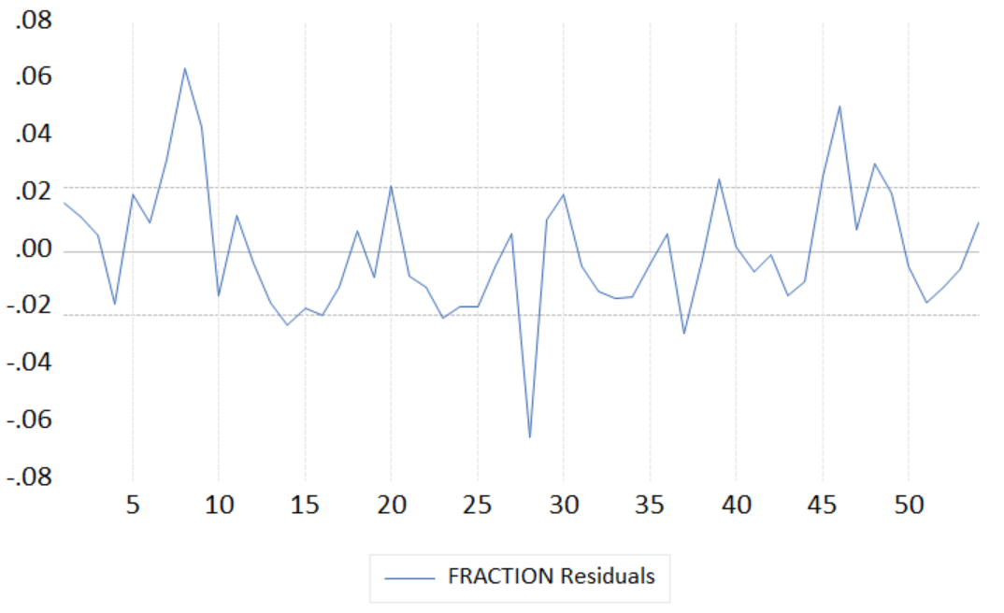
Figure 1 Residual plot

Question 1(c)
Model:
$$fraction=β_{0}+ β_{1}total+ β_{2}size+u$$
Hypothesis test:
$$H_{0} :Var\left(u \right| total, size)=E\left(u^{2} \right| total, size)= σ^{2}I_{54}$$
$$H_{1} :Var\left( u | Total,Size\right) is a smooth function of total and size$$
Auxiliary Regression:
$${\hat{u}}^{2}=∝_{0}+∝_{1}total+ ∝_{2}size+ ∝_{3}{total}^{2}+∝_{4}{size}^{2}+∝_{5}total×size+v$$
White test statistic:
$$W=54×R_{{\hat{u}}^{2}}^{2} \sim χ^{2}(5) under H_{0}$$
Calculate White test statistic:
$$W_{cal}=54 ×0.142=7.67$$
Using this estimated auxiliary regression for $R_{{\hat{u}}^{2}}^{2}$:
$${0.001 \atop \left(0.001\right)}+{0.001 \atop \left(0.002\right)}total-{0.000 \atop \left(0.000\right)}size+ {0.000 \atop \left(0.001\right)}{total}^{2}+{0.000 \atop \left(0.000\right)}{size}^{2}-{0.000 \atop \left(0.000\right)}total×size$$
See Appendix for Question 1.
Calculate White critical value @ 5 level of significance:
$$χ^{2}(5)=11.07$$
Decision rule:
$$Reject H_{0 }if W_{cal}>χ^{2}(5)$$
As $W_{cal}=7.62<χ^{2}\left(5\right)=11.07$, there insufficient evident to reject the null hypothesis that are homoskedastic errors ($E\left(u^{2} \right| total, size)= σ^{2}I_{54}$) for our linear regression model at the 5% level of significance.

Question 1(d)
The White test with fitted values has an auxiliary regression:
$${\hat{u}}^{2}=α_{0}+α_{1}\hat{fraction}+α_{2}{\hat{fraction}}^{2}+v$$
Given that the White calc is: $W_{cal}=54 ×0.058=3.133$,
We do not reject the null hypothesis that errors are homoskedastic as $W_{cal}=3.133<χ^{2}\left(5\right)=11.07$ at 5% level of significance. From this, there is no reason to believe that the White test with fitted values will be a better idea. However, given that the Akaike Information Criterion (AIC) is -11.241 compared to the ordinary White test where AIC is -11.224 for the auxiliary regression, there may be reason to prefer this White test over the previous one. However, given that the adjusted $R^{2}$ declines from 0.053 to 0.021, we believe that there its hardly justificatory to choose this model over the other, nonetheless.
See Appendix for Question 1.

Question 1(e)
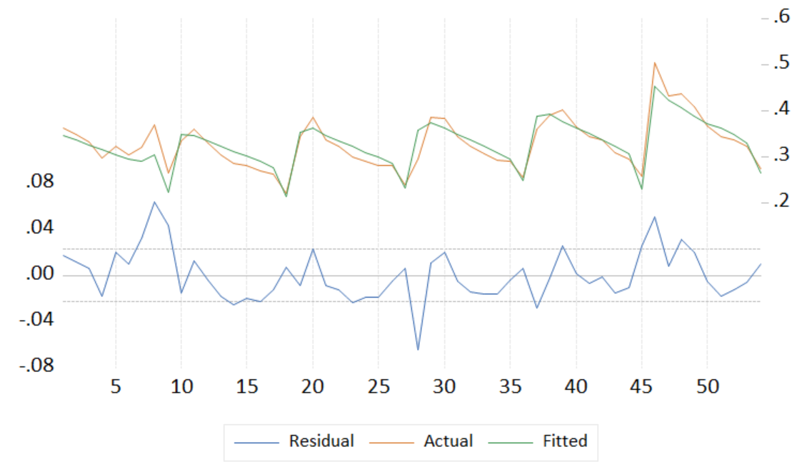
Figure 2 Line and residual plot
The line graph of the residuals (the top graph in Figure 2) shows that there is a cyclical pattern, where positive residuals are followed by positive residuals and negative residuals are followed by negative residuals, as indicated by the peaks and troughs. The residuals in the series carry over into the future periods, which can be observed by the cyclical pattern. It is unlikely that this pattern is white noise, thus we can say that the graph indicates serially correlation.

Question 1(f)
Linear regression model:
$$fraction_{i}= β_{0}+β_{1}total_{i}+ β_{2}size_{i}+u_{i}$$
$$u_{i}=ρ_{1}u_{i-1}+e_{i}$$
$$e_{i}∼N(0, σ^{2})$$
Hypothesis test:
$$H_{0} :ρ_{1}=0$$
$$H_{1} :ρ_{1}≠0$$
Auxiliary Regression:
$$\hat{u}=∝_{0}+∝_{1}total_{i}+∝_{2}size_{i}+α_{3}u_{i-1}+v_{i}$$
Bruesch-Godfrey test statistic:
$$BG=(54-1)×R_{\hat{u}}^{2} \sim χ^{2}(1) under H_{0}$$
Calculate White test statistic:
$$W_{cal}=53 ×0.132=6.98$$
Using this estimated auxiliary regression for $R_{\hat{u}}^{2}$:
$${-0.004 \atop \left(0.008\right)}+{0.000 \atop \left(0.001\right)}total_{i}+ {0.000 \atop \left(0.001\right)}size_{i}+{0.369 \atop \left(0.136\right)}u_{i-1}$$
See Appendix for Question 1.
Calculate White critical value @ 5 level of significance:
$$χ^{2}(1)=3.84$$
Decision rule:
$$Reject H_{0 }if W_{cal}>χ^{2}(1)$$
As $W_{cal}=6.98>χ^{2}\left(1\right)=3.84$, there is sufficient evidence to reject the null hypothesis that there is no first order autocorrelation in our regression model for the alternative that there is at 5% level of significance.

Question 1(g)
There are two ways to correct for autocorrelation in our model (as per our results in 1(c) and 1(f)).
From 1(c), we know that there is no evidence to suggest heteroskedasticity in our linear model, and from 1(f), that there is evidence to suggest there is autocorrelation however at the 5% level of significance. To correct for autocorrelation, therefore, we may have two methods. Our first method is to use HAC standard errors instead (which uses autocorrelation-robust standard errors). Our regression from this:
$$\hat{fraction}={0.335 \atop \left(0.010\right)}-{0.154 \atop \left(0.009\right)}total+{0.015 \atop \left(0.003\right)}size$$
A simple OLS regression of fraction on total and size is:
$$\hat{fraction}={0.345 \atop \left(0.008\right)}-{0.154 \atop \left(0.011\right)}total+{0.015 \atop \left(0.002\right)}size$$
Plotting the correlogram

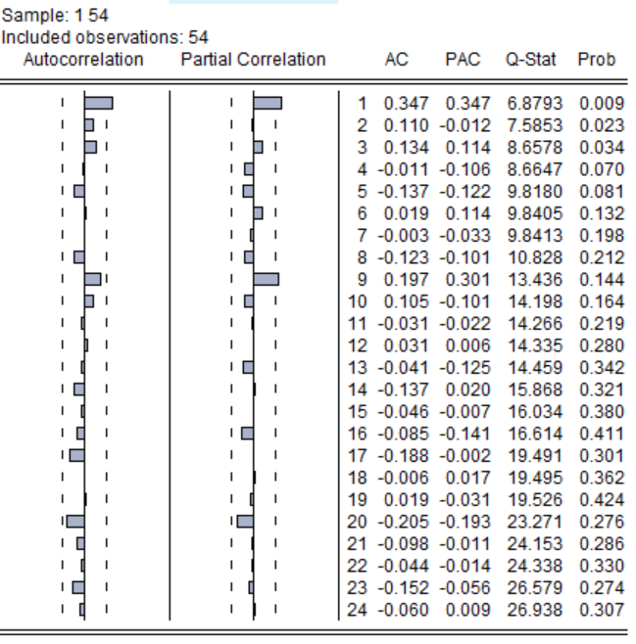
Figure 3 Correlogram of HAC OLS regression

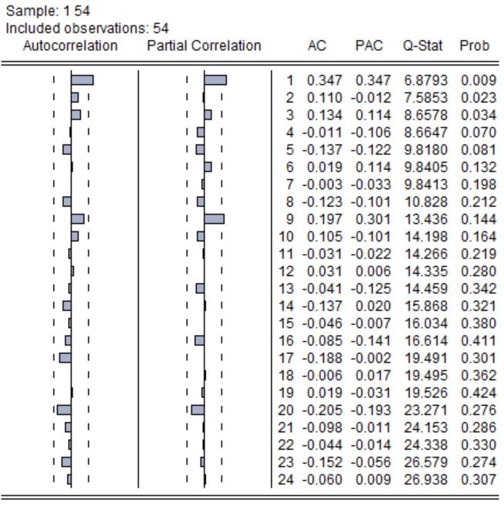
Figure 3 Correlogram of OLS regression
It can be seen from Figure 3 and 4 that there is no difference in autocorrelation between the regressions. Moreover, from Figure 5 and 6 it can be seen that in a test of joint significance of all regressors, or a test of individual significance of each regressor, at 5% level of significance, all are significant. The only difference is that the HAC standard errors are smaller than the normal OLS standard errors.

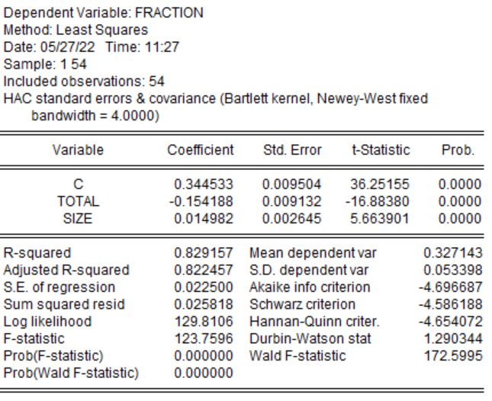
Figure 5 OLS regression of fraction on total and size

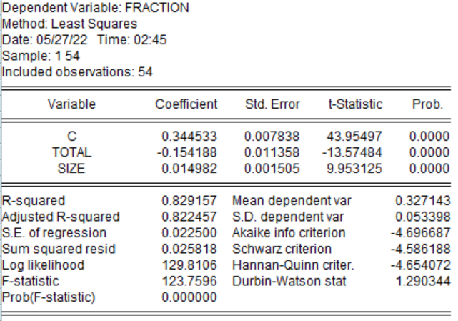
Figure 6 OLS regression of fraction on total and size with HAC
The second method is to estimate the regression for the model:
$$fraction_{i}=β_{0}+β_{1}total_{i}+β_{2}size_{i}+α_{1}{fraction}_{i-1}+u_{i}$$
As our results from 1(g) suggest the presence of first order autocorrelation.
This gives us an estimated equation of
$$\hat{fraction}={0.333 \atop \left(0.012\right)}-{0.138 \atop \left(0.012\right)}total+{0.016 \atop \left(0.002\right)}size+{0.423 \atop \left(0.131\right)}fraction_{i-1}$$
From Figure 7, it can be seen that our regression shows statistical significance for all regressors, individually and jointly, at the 5% level of significance. Our standard errors are also larger, however, than our normal OLS regression. However, from our correlogram from Figure 8, there is reason to prefer this model as our first-order AC is no longer significant compared to the ordinary OLS regression one in Figure 4.
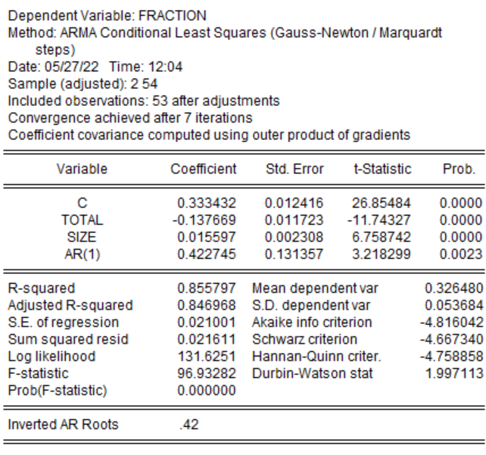
Figure 7 OLS Regression with AR(1) using CLS
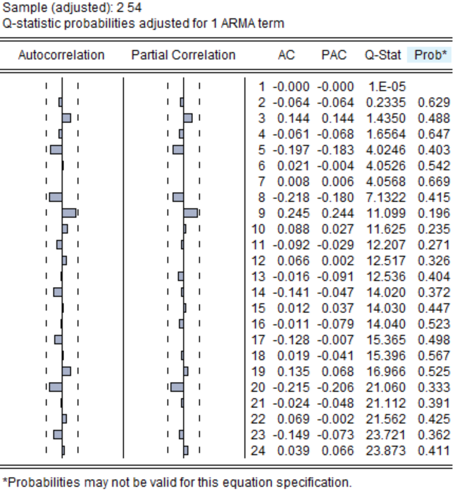
Figure 8 Correlogram of regression with AR(1)

Appendix for Question 1

Question 1(c)
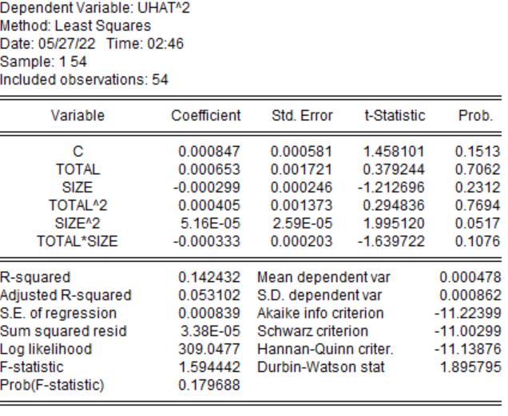
Question 1(d)
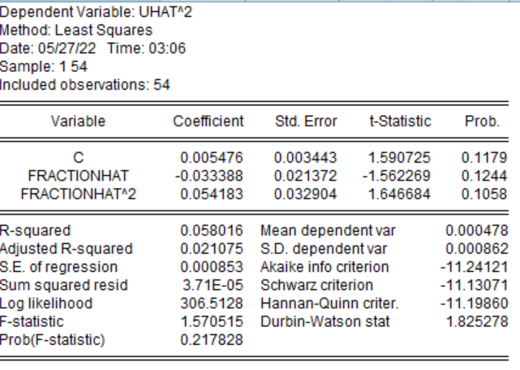
Question 1(f)
